


COLLEGE CODE:9612

COLLEGE NAME: LOYOLA INSTITUTE OF TECHNOLOGY AND SCIENCE

DEPARTMENT: COMPUTER SCIENCE AND ENGINEERING

STUDENT NM-ID: 3D8F086A7AD8DAB86F645224BC12D12F

ROLL NO:961223104017

TECHNOLOGY PROJECT NAME: SINGLE PAGE APPLICATION

SUBMITTED BY
NAME:M.BLESSY MERLIN

SINGLE PAGE APPLICATION
AIM
The primary aim of this project was to design, develop, and deploy a fully functional Single Page Application (SPA) that demonstrates modern web development principles. The core objective was to eliminate the traditional multi-page website model's inefficiencies by creating a dynamic web application that loads a single HTML page and dynamically updates its content as the user interacts with it, thereby providing a seamless, fast, and app-like user experience without full page reloads.

DESCRIPTION:
This project involved the complete design and development of a modern Single Page Application (SPA) to solve the problem of slow, disruptive page reloads in traditional websites. The application was built using HTML, CSS, and JavaScript, featuring dynamic navigation, user authentication, real-time content updates, and a responsive design. The project followed a structured 5-phase approach from planning and architecture through implementation, enhancement, and final deployment.

Phase 1: Problem Understanding & Requirements
Problem Statement & Objective
Modern web users demand seamless, fast experiences. Traditional multi-page websites cause delays and poor user experience due to constant browser reloads for each new page. The key challenge addressed by a Single Page Application (SPA) is the elimination of these full-page reloads. The primary objective is to provide a web application that allows users to interact with the website without page refreshes, leading to a fluid, app-like experience.
Users & Stakeholders
Identifying users and stakeholders is essential to align the project with the needs of all parties.
- End Users: The primary individuals who interact with the application. Their needs, goals, and behaviors define the features and UI/UX design.
- Product Manager: Ensures the project aligns with business goals, prioritizes features, and handles resource allocation.
- UI/UX Designers: Responsible for creating a user-friendly, visually appealing, and functional design.
- Frontend Developers: Implement the visual and interactive aspects using technologies like React, Vue, or Angular.
- Backend/API Developers: Design and implement the RESTful APIs that handle user data, authentication, and data processing.
- Quality Assurance (QA) Engineers: Ensure the app meets functionality, performance, and business requirements through comprehensive testing.
User Stories & Acceptance Criteria
User stories describe features from the end user's perspective.
- User Authentication: As a user, I want to log in and register so I can access my dashboard.
  - Criteria: Input email/password, feedback on failed attempts, redirect to dashboard on success.
- Real-Time Data Updates: As a user, I want to see real-time updates on my dashboard.
  - Criteria: Data updates without refresh, user-customizable updates.
- Profile Management: As a user, I want to manage my profile settings and change my password.
  - Criteria: Update profile picture, email, personal details, and change password securely.
- Admin Dashboard: As an admin, I want to manage user accounts and monitor activity.
  - Criteria: View user details, approve/reject posts.
MVP Features
The Minimum Viable Product includes the core features for a functional SPA.
- Dynamic Routing: Navigate between views without reloads (e.g., using React Router).
- Authentication: User login, sign-up, and session management (e.g., using JWT tokens).
- API Integration: Communicate with backend services via RESTful APIs for data.
- Real-Time Data: Live updates for notifications or messages (e.g., via WebSockets).
- State Management: Centralized state management (e.g., Redux, Context API).
- Responsive Design: The UI adjusts gracefully to different screen sizes.
Wireframes & API Endpoints
- Wireframes: Focus on layout and dynamic interactions.
  - Home Page: Navbar, hero section.
  - Login/Signup Page: Form fields, error messages.
  - Dashboard & Profile Page: Data display, forms for editing.
- API Endpoints:
  - Authentication: POST /api/login, POST /api/register, GET /api/logout.
  - User Data: GET /api/user/profile, PUT /api/user/update.
  - Content: GET /api/posts, POST /api/posts, GET /api/posts/{id}.
  - Real-time: GET /api/notifications.

Phase 2: Tech Stack & Architecture
Tech Stack Selection
Choosing the right technologies is crucial for a robust and maintainable SPA.
- Frontend:
  - Frameworks/Libraries: React.js, Angular, or Vue.js for component-based architecture.
  - Routing: React Router, Vue Router, or Angular Router for navigation without reloads.
  - State Management: Redux, MobX, Vuex, or React's Context API.
- Backend (API Server):
  - Languages/Frameworks: Node.js + Express, Django (Python), Spring Boot (Java).
  - Database: SQL (PostgreSQL, MySQL) or NoSQL (MongoDB).
- Other Tools:
  - Authentication: OAuth 2.0, JWT, Firebase Auth.
  - Build Tools: Webpack, Vite, Parcel.
  - Deployment: Vercel/Netlify (frontend), Heroku/Render/AWS (backend).
UI Structure / API Schema Design
- UI Structure:
  - Component-Based Architecture: UI broken into reusable components (e.g., NavBar, ProductCard).
  - Layout Composition: Header, footer, sidebar, and main content areas.
  - Dynamic Routing: URL routes (e.g., /dashboard, /profile/:id) map to specific views.
- API Schema Design:
  - RESTful Design: Use standard HTTP methods (GET, POST, PUT, DELETE).
  - Resource Endpoints: e.g., GET /api/users, POST /api/users, PUT /api/users/:id.
  - Versioning & Consistency: Use versioning (/api/v1/) and consistent JSON response formats.
Data Handling Approach
Efficient data handling ensures responsiveness and reliability.
- Client-Side State Management:
  - Local State: Managed within components using hooks or local variables.
  - Global State: For data shared across components (e.g., user session), using Redux or Context API.
- API Communication:
  - Use Axios, Fetch, or libraries like React Query for data fetching and caching.
  - Implement Lazy Loading and Code Splitting for performance.
  - Use Optimistic UI Updates for a faster perceived performance.
- Error Handling, Caching & Persistence:
  - Centralized error boundaries and user-friendly messages.
  - Use localStorage/sessionStorage for tokens/preferences.
  - Data revalidation to keep the UI updated.
Component / Module Diagram
A high-level view of the SPA's architecture.
- App Component: The root component that handles routing and overall layout.
- Header/Nav Component: Persistent navigation bar.
- Main View Area: Dynamically renders components based on the current route (e.g., Dashboard, Profile Page, Login).
- Footer Component: Persistent footer.
- Supporting Modules:
  - Routing Module: Manages view rendering based on URL.
  - State Management Module: Manages global and local state.
  - API Service Module: Handles all backend communication.
  - Auth Module: Manages token handling and route guards.
  - Utilities Module: Contains helpers and validation functions.
SPA Lifecycle Flow Diagram
The runtime flow from initial load to user interaction.
- User enters the application URL.
- Initial index.html is loaded by the browser.
- JavaScript bundles (App.js, etc.) are loaded.
- The App Component is mounted.
- The Router checks the URL and loads the corresponding view component.
- Component lifecycle begins (e.g., useEffect or mounted runs).
- API requests are sent via the service module.
- Backend responds with JSON data.
- Data is passed to the component via props or state.
- The UI re-renders with the new data.
- User interactions trigger state changes or new API calls, repeating the flow without full page reloads.

Phase 3: MVP Implementation
Project Setup
The foundation is laid by setting up the development environment.
- Framework and Technology Selection: Choose a frontend framework (React, Vue, Angular) and initialize the project with a package manager (npm/yarn).
- Development Environment Configuration: Set up a development server with hot-reload. Configure environment variables for different stages (dev, staging, prod). Integrate code formatting (Prettier) and linting (ESLint) tools.
Core Features Implementation
Building the essential functionalities of the SPA.
- Dynamic Routing System: Implement client-side routing for navigation without reloads. Configure route definitions, navigation components, and route guards for protected pages. Handle nested routes and dynamic segments.
- User Authentication System: Build a secure system for registration, login, logout, and session management using JWT tokens. Includes form validation, error handling, protected routes, and token refresh mechanisms.
- API Integration Layer: Create a robust service layer for backend communication. Configure HTTP clients, request/response interceptors for automatic token attachment, and error handling middleware.
- State Management Implementation: Set up centralized state management (e.g., Redux) to handle global application state, user authentication status, and shared data between components using actions, reducers, and selectors.
Data Storage (Local State / Database)
Managing data on the client and server.
- Client-Side State Management: Use component state (e.g., React hooks) for UI-specific data like form inputs and modal visibility.
- Persistent Storage Solutions: For the SPA artifact, use in-memory storage (JavaScript variables) to simulate persistence. Browser storage (localStorage) can be used for tokens or preferences.
- Backend Integration: Communicate with backend services via RESTful APIs for permanent data storage (user profiles, posts). Implement data synchronization strategies like optimistic updates.
Testing Core Features
Ensuring the reliability and quality of the implementation.
- Unit Testing Framework: Test individual components and functions using Jest or Vitest. Aim for high test coverage.
- Integration Testing: Test interactions between components, API integration, routing, and authentication flows. Use mock services to simulate backend responses.
- User Acceptance Testing (UAT): Validate features against the defined acceptance criteria. Test user workflows, form submissions, error scenarios, and responsive design across devices.
Version Control (GitHub)
Managing code and collaboration.
- Repository Management: Use a clear branching strategy (e.g., main branch for stable code, feature branches for development). Implement pull request workflows for code review.
- Commit Standards: Use semantic commit messages for better project history and maintainability.
- Deployment Pipeline (CI/CD): Automate testing and deployment using GitHub Actions. Build production assets and deploy to platforms like Netlify or Vercel.
  - Documentation and Collaboration: Maintain comprehensive README files, API documentation, and use issue tracking for managing development

Phase 4: Enhancements & Deployment
Additional Features
Expanding the application's functionality post-MVP.
- Implement advanced features like search functionality with dynamic filters.
- Add user profile pages with detailed views and activity history.
- Integrate real-time notifications or chat functionality to increase user engagement.
UI/UX Improvements
Refining the interface and experience for better usability.
- Polish animations and transitions for smoother navigation.
- Make responsive design adjustments for a consistent experience on all devices.
- Improve accessibility (a11y) by adding ARIA labels and ensuring keyboard navigation.
- Optimize layouts and visual hierarchy for better readability and user flow.
API Enhancements
Strengthening the backend integration.
- Add new API endpoints to support additional features.
- Secure existing endpoints with rate limiting and robust authentication checks.
- Optimize database queries and API logic to improve response times.
- Enhance error handling to provide clear, actionable messages to the frontend.
Performance & Security Checks
Ensuring the application is fast and secure.
- Performance: Minify CSS and JavaScript files. Optimize images and implement lazy loading for components and images.
- Security: Protect against common vulnerabilities like XSS (Cross-Site Scripting) and CSRF (Cross-Site Request Forgery). Implement HTTPS, configure CORS policies correctly, and set security headers.
Testing of Enhancements & Deployment
Validating new features and going live.
- Testing: Perform unit, integration, and end-to-end tests (using tools like Cypress) on all new enhancements. Conduct manual testing to catch UI/UX issues.
- Deployment: Deploy the final SPA to a live platform.
  - Frontend: Use services like Netlify or Vercel for static hosting.
  - Full-Stack: Use cloud platforms like AWS, Azure, or IBM Cloud.
  - Process: Set up CI/CD pipelines, configure environment variables for production, and monitor application performance post-deployment.

Phase 5: Demonstration & Documentation
Final Demo Walkthrough
The demonstration showcases the complete, deployed SPA. It highlights smooth navigation between sections (Home, Dashboard, Posts, Profile) without page reloads. Key interactions like user login, creating a new post, and viewing dynamic dashboard statistics are performed live. The demo emphasizes the responsive design and the seamless user experience achieved.
Project Report
This project successfully designed and implemented a Single Page Application using HTML, CSS, and JavaScript. The primary goal was to eliminate page reloads, providing a fast, app-like user experience. The application features dynamic content loading, client-side routing, and a simulated backend interaction, demonstrating the core principles of a modern SPA.
Screenshots & API Documentation
- Screenshots: Included for key application pages: Login screen, Homepage with feature overview, Dashboard with analytics, User Management, and Profile Settings.
- API Documentation:
  - POST /api/login: Authenticates a user. Expects { email, password }.
  - GET /api/users: Fetches a list of users.
  - GET /api/data/:id: Fetches a specific data item by ID.
  - Each endpoint is documented with expected parameters, response format, and HTTP status codes.
Challenges & Solutions
A summary of key development hurdles and how they were overcome.
Challenge | Solution
Integrating frontend with backend APIs | Implemented CORS and consistent JSON data exchange formats.
Handling state efficiently in a SPA | Used React Context API / Redux for centralized state management.
Optimizing application load time | Implemented lazy loading for components and cached static assets.
Resolving deployment issues | Correctly configured environment variables and build output paths.
GitHub README & Setup Guide
The README file provides all necessary information to run the project.
- Project Overview: A brief description of the SPA.
- Tech Stack: HTML, CSS, JavaScript.
- Installation Instructions:
bash
git clone <repo_url>
cd project-folder
# Since it's static, open index.html in a browser or use a local server.
- Environment Setup: Instructions for any required environment variables.
- Usage Guide: Steps to use the app, including demo login credentials.
- File Structure:
text
spa-project/
├── index.html
├── styles.css
└── script.js
Final Submission
The project conclusion includes all deliverables.
- GitHub Repository Link: Contains the complete source code and README.
- Deployed Application Link: The live URL hosted on a platform like Netlify or Vercel.
- Documentation Folder: A comprehensive PDF or Markdown file containing all screenshots, API documentation, and the challenges/solutions report.
Program:
FILE NAME:index.html
<!DOCTYPE html>
<html lang="en">
<head>
<meta charset="UTF-8">
<meta name="viewport" content="width=device-width, initial-scale=1.0">
<title>Single Page Application - Project</title>
<link rel="stylesheet" href="styles.css">
<link href="https://cdnjs.cloudflare.com/ajax/libs/font-awesome/6.0.0/css/all.min.css" rel="stylesheet">
</head>
<body>
<!-- Navigation -->
<nav class="navbar">
<div class="nav-container">
<div class="nav-logo">
<i class="fas fa-layer-group"></i>
<span>SPA Project</span>
</div>
<div class="nav-menu">
<a href="#" class="nav-link active" onclick="showSection('home')">
<i class="fas fa-home"></i> Home
</a>
<a href="#" class="nav-link" onclick="showSection('dashboard')">
<i class="fas fa-chart-bar"></i> Dashboard
<div class="nav-actions">
<button class="btn-login" onclick="showSection('login')">
<i class="fas fa-sign-in-alt"></i> Login
</button>
</div>
</div>
</nav>

<!-- Main Content -->
<main class="main-content">
<!-- Login Section -->
<section id="login" class="content-section active">
</form>
</div>
</div>
</div>
</section>
</main>

<script src="script.js"></script>
</body>
</html>
File Name:script.js
// SPA Navigation
function showSection(sectionId) {
// Hide all sections
document.querySelectorAll('.content-section').forEach(section => {
section.classList.remove('active');
});
// Update URL hash
window.location.hash = sectionId;

// Load section-specific data
loadSectionData(sectionId);
}

// Handle login
function handleLogin(event) {
event.preventDefault();
const email = document.getElementById('email').value;
const password = document.getElementById('password').value;
// Add some interactive features
function simulateRealTimeUpdates() {
setInterval(() => {
if (document.getElementById('dashboard').classList.contains('active')) {
updateDashboardStats();
}
}, 10000); // Update every 10 seconds
}

// Start real-time updates
simulateRealTimeUpdates();
FILE NAME:styles.css
* {
margin: 0;
padding: 0;
box-sizing: border-box;
}

:root {
--primary: #4361ee;
--secondary: #3a0ca3;
--success: #4cc9f0;
--danger: #f72585;
--warning: #f8961e;
--dark: #2b2d42;
--light: #f8f9fa;
--gray: #6c757d;
--border: #e9ecef;
--shadow: 0 4px 6px -1px rgba(0, 0, 0, 0.1);
}
/* Navigation */
.navbar {
background: rgba(255, 255, 255, 0.95);
backdrop-filter: blur(10px);
border-bottom: 1px solid var(--border);
position: fixed;
top: 0;
width: 100%;
z-index: 1000;
}

.nav-container {
max-width: 1200px;
margin: 0 auto;
display: flex;
align-items: center;
justify-content: space-between;
padding: 1rem 2rem;
}

.nav-logo {
display: flex;
align-items: center;
gap: 0.5rem;
font-size: 1.25rem;
font-weight: 700;
color: var(--primary);
}

.nav-logo i {
font-size: 1.5rem;
}

.nav-menu {
display: flex;
gap: 1.5rem;
}

.nav-link {
display: flex;
align-items: center;
gap: 0.5rem;
text-decoration: none;
color: var(--gray);
font-weight: 500;
padding: 0.5rem 1rem;
border-radius: 8px;
transition: all 0.3s ease;
}

.nav-link:hover,
.nav-link.active {
color: var(--primary);
background: rgba(67, 97, 238, 0.1);
}
.btn-login:hover {
background: var(--secondary);
}

/* Main Content */
.main-content {
margin-top: 80px;
min-height: calc(100vh - 80px);
}

.content-section {
display: none;
animation: fadeIn 0.5s ease-in;
}

.content-section.active {
display: block;
}

@keyframes fadeIn {
from { opacity: 0; transform: translateY(20px); }
to { opacity: 1; transform: translateY(0);
}

.activity-content span {
font-size: 0.875rem;
color: var(--gray);
}

/* Users Section */
.users-grid {
display: grid;
}

.user-card {
.user-card img {
width: 80px;
height: 80px;
border-radius: 50%;
margin-bottom: 1rem;
border: 3px solid var(--primary);
}

.user-card h3 {
margin-bottom: 0.5rem;
}

.user-card p {
color: var(--gray);
margin-bottom: 1rem;
}
.user-status.inactive {
background: rgba(108, 117, 125, 0.1);
color: var(--gray);
}

/* Posts Section */
.posts-container {
.btn-create {
background: var(--primary);
color: white;
border: none;}

.btn-create:hover {
background: var(--secondary);
}

.post-item {
background: white;
padding: 1.5rem;
border-radius: 8px;
margin-bottom: 1rem;
border-left: 4px solid var(--primary);
box-shadow: 0 2px 4px rgba(0,0,0,0.1);
}
.post-item p {
color: var(--gray);
margin-bottom: 1rem;
}
.hero-section h1 {
font-size: 2rem;
}

.section-header h2 {
font-size: 2rem;
}
}

OUTPUT:

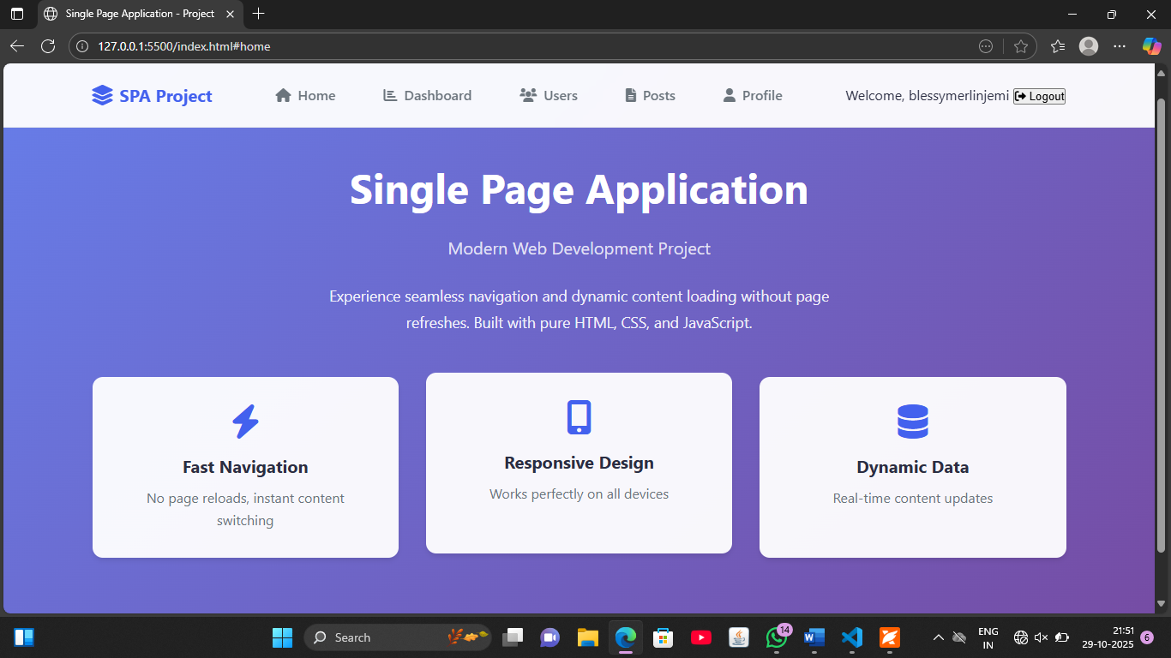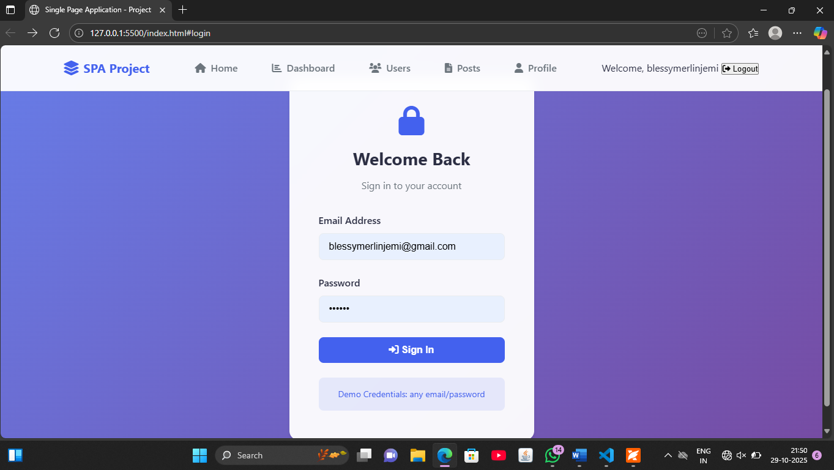

RESULT:
Successfully built and deployed a fully functional Single Page Application that provides seamless, app-like navigation without page reloads.

